LEAF PROJECT
(Locally Encouraging All to Flourish)

Trustees’ Update: February 2021
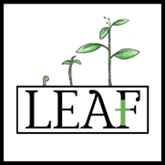
“I pray also for those who will believe in me through their message…
so all of them may be one, Father, just as you are in me and I am in you…
so that the world may believe that you have sent me” (John 17:20-21)

Introduction
LEAF (Locally Encouraging All to Flourish) has been established with the express purpose of taking the love of Christ into the town of Ledbury. Its primary focus will be the development of a range of social action projects and with charity status it will be able to access a level of grant funding not so easily accessible to mainstream churches.
Charity Objects
The charity has the following objects (these are taken from the constitution submitted to the Charity Commission)
The following objects of the CIO will be undertaken in accordance with the Christian faith and its moral and ethical framework:
To promote the holistic welfare of the inhabitants of Ledbury who are experiencing isolation, poor mental health, financial or other disadvantage as a result of social circumstance, through the provision of support services that enable local people to achieve their potential and thrive. Including: pastoral care, peer support groups, social groups, therapeutic support and debt advice.
Charity Application Status
As you might imagine the application for charity status is not straightforward and we are working with Futurekraft – a Christian company that works with Christian charities on funding and charity commission applications. We have presented an initial draft set of documents to the commission and are now working with them to amend and clarify aspects of the work. It is our hope that charity status will be granted in early Spring.
Organisational Structure
The charity operates under the leadership of Tony Hodder who acts as the Chief Executive Officer. However, the day-to-day management of the work is undertaken by a range of project leaders from across the churches. These different strands are outlined in the organisational diagram below and seek to cover the areas of physical, emotional and spiritual well-being. The charity is overseen by the trustees. These comprise of the church leaders in the town who operate as ex-officio trustees, Peter Williamson, Derek Chedzey (Archdeacon of Hereford) and Anna Nugent (County Ecumenical Officer)
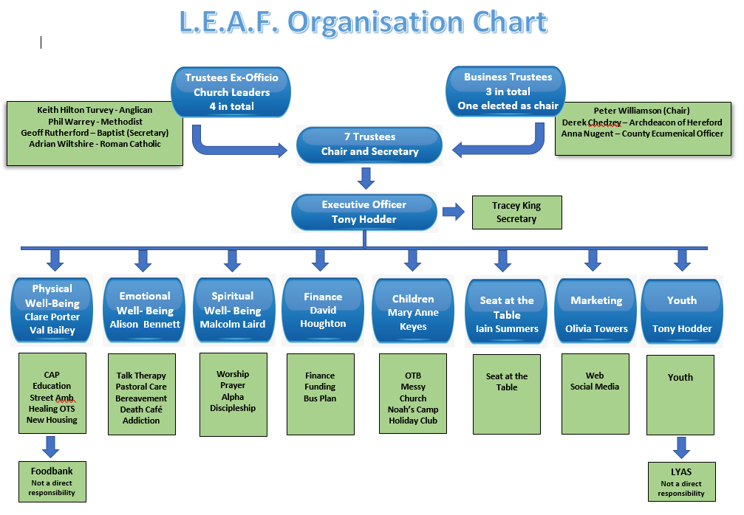

Current plans
The trustees now have a regular meeting schedule and will be meeting once a quarter. The project team leaders meet monthly. Initial activities primarily build on those established prior to the development of LEAF but others are moving forward under the charity’s umbrella. A debt centre will be established in the town under the auspices of CAP (Christians Against Poverty) and will soon be running CAP money courses. The website is in the process of being built and will soon go live. Some free counselling work is being done and will be expanded over time. Two Alpha courses are currently running simultaneously. A ‘Real Easter Egg’ project is underway aimed at providing an Easter Egg together with an Easter story booklet to children in primary schools who are entitled to free school meals. Pastoral care for people outside or on the fringes of church is being provided for a range of people needing support. Over the next few months, we will be considering several new projects for delivering later this year and in future years.
Funding application progress
LEAF submitted an application for “Total Return Funding” from the diocese. This was successful and will enable the charity to draw on £50,000 over five years and whilst it would still mean that the local churches would fund Tony’s salary it would enable the current arrangement (where the diocese fund the rent) to continue.
In support of Leaf the Methodist church has applied for funding to support the setup of the debt counselling and money training courses. It is too early to know if this has been successful.

How will we work with our local community?
We are still in the process of establishing the charity and most of the contact so far has come from personal contact or word of mouth. However, the intention is to make the services of the charity available to as many as possible. The team are considering ways of making these as accessible as possible and once the web site is established, we will be able to provide further details.
What are the next steps?
The next immediate step is to complete the awarding of charity status. Once this is finalised, we will be able to set up a bank account for the charity, this cannot be undertaken without the official charity number. There are then a series of policies and documentation to produce. These include Safeguarding policies and Health and Safety procedures along with an ethos statement that all working with the organisation should seek to uphold. Finally, a 5-year project plan was drafted for the diocesan bid and the first year of this will provide a focus for the project team in the short-term.

